(EDUNET-FOUNDACTION) SUMMER INTERNSHIP EMPLOYEE BURNOUT PREDICTION

A Summer Internship report submitted in partial fulfilment of the requirements for the award of the degree of

BACHELOR OF TECHNOLOGY
in
CSE – ARTIFICIAL INTELLIGENCE
Submitted by
RASAMSETTI LAKSHMI KALYANI

(22JN1A4311)
Under the Guidance of
[NAGESH SINGH]

Assistant Professor CSE - (AI)


DEPARTMENT OF ARTIFICIAL INTELLIGENCE

KAKINADA INSTITUTE OF ENGINEERING AND TECHNOLOGY FOR WOMEN
(Approved by APSSDC& Affiliated to JNTUK, Kakinada & Accredited by NAAC) Yanam Road, Korangi, Andhra Pradesh

CERTIFICATE

This is to certify that the report entitled “EDUNET FOUNDACTION SUMMER
INTERNSHIP”, that is being submitted by RASAMSETTI LAKSHMI KALYANI of III Year I Semester bearing(22JN1A4311) in partial fulfilment for the award of the Degree of Bachelor of Technology in Computer Science and Engineering Artificial intelligence Kakinada Institute of Engineering and Technology is a record of bona fide work carried out by them.

Internal Examiner Department
Head of the deportment External Examiner.

Student’s Declaration

I RASAMSETTI LAKSHMI KALYANI a student of BACHELOR OF
TECHNOLOGY program, Reg. No:22JN1A4311 of the Department of CSE (ARTIFICIAL
INTELLIGENCE), KAKINADA INSTITUTE OF ENGINEERING AND
TECHNOLOGY FOR WOMEN’S do hereby declare that I have completed the mandatory internship from 03-JUNE 2024 to 15-JULY 2024 in EUDNET-FOUNDACTION
SUMMER INTERNSHIP under the Faculty guidance of Mr. NAGESH SINGH, B. Tech,
Department of CSE – ARTIFICAL INTELLIGENCE, KAKINADA INSTITUTE OF
ENGINEERING AND TECHNOLOGY FOR WOMEN

(Signature and Date)

COMPLETION

CERTIFICATE

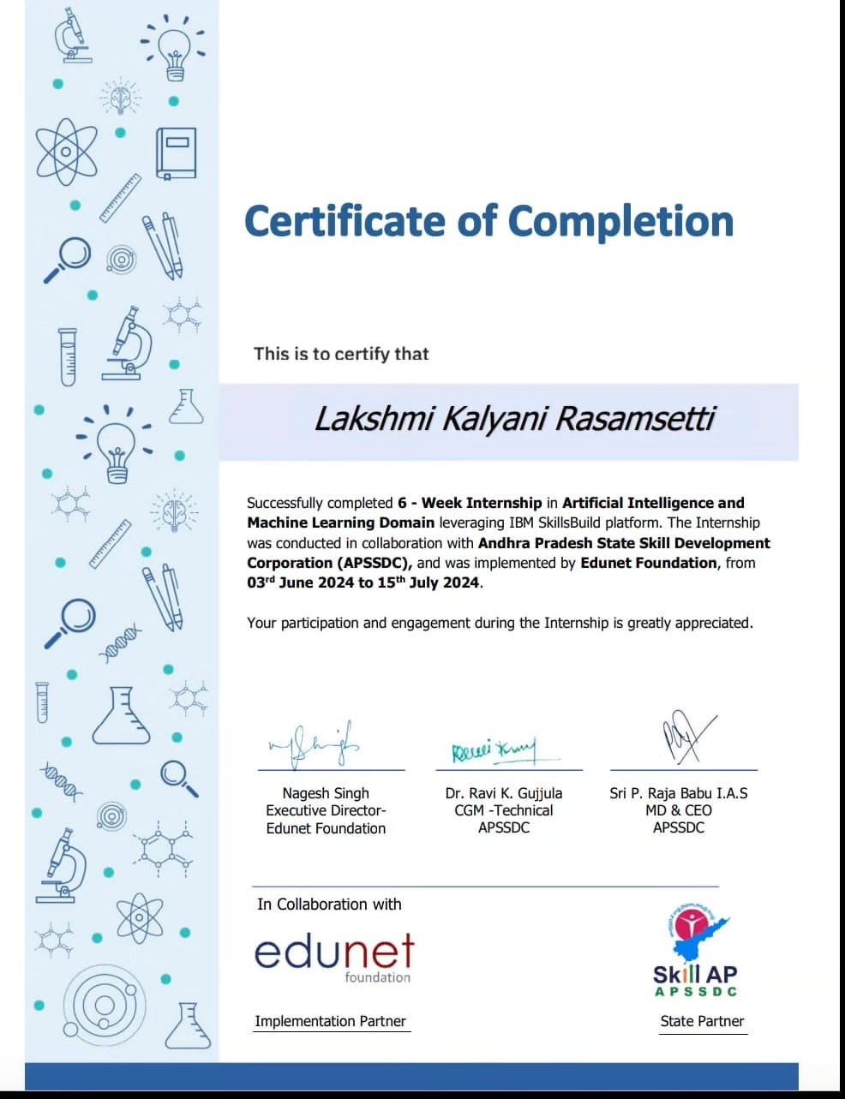

Official Certification

This is to certify that RASAMSETTI LAKSHMI KALYANI I Reg. No: 22JN1A4311 has completed his/her internship in EDUNET-FOUNDACTION on APSSDC SUMMER Internship under my supervision as a part of partial fulfilment of the requirement for the Degree of B. TECH (CSE- CAI) in the Department of
KAKINADA INSTITUTE OF ENGINEERING AND TECHNOLOGY FOR
WOMEN’S
This is accepted for evaluation.

(Signatory with Date and Seal)

Endorsements

Faculty Guide
Head of the Hod Principal

ACKNOWLEDGEMENTS

It gives us an immense Pleasure to express a deep sense of gratitude to our
supervisor NAGESH SINGH Assistant Professor, Department of CSE – ARTIFICIAL INTELLIGENCE because of his whole hearted and valuable guidance throughout the report. Without his sustained and sincere effort, this report would not have taken this shape. He encouraged and helped us to overcome various difficulties that we have faced at various stages of our report.
We would like to sincerely thank our supervisor NAGESH SINGH Assistant Professor for providing all the necessary facilities that led to the successful completion of our report.
We would like to sincerely thank SRI P. RAJA BABU I.A.S Assistant Professor & HOD of ARTIFICIAL INTELLIGENCE (CAI), for providing all the
necessary facilities that led to the successful completion of our report.
We would like to take this opportunity to thank our beloved Principal RAMA KRISHNA for providing a great support to us in completing our project and for giving us the opportunity of doing the internship report.
Finally, we would like to thank all of our friends and family members for their continuous help and encouragement.

RASAMSETTI LAKSHMI KALYANI
22JN1A4311

- INTERNSHIP INTRODUCTION

- WEEKLY REPORT

3. CONCLUSION

INTERNSHIP INTRODUCTION Employee burnout is a state of emotional, physical, and mental exhaustion, physical, and mental exhaustion caused by prolonged or excessive stress.
MPLOYEE BURNOUT IS A STATE OF EMOTIONAL,
PHYSICAL, AND MTABLE OF CONTENT

CHAPTER NO. TITLE

- introduction to the data analysis

- Aim and scope

- Experiments or requirements

- Results

- Summary and discussions

WEEKLY REPORT

INTRODUCTION TO THE DATA ANALYSIS

Data Analysis is the process of bringing order and structure to collected data. It turns data into information teams can use. Analysis is done using systematic methods to look for trends, groupings, or other relationships between different types of data.

Data Visualization is the discipline of trying to understand data by placing it in a visual Context so that pattern, trends and correlations that might not otherwise be detected can be exposed.

Python offers multiple great graphing libraries that come packed with lots of different features. No matter if you want to create interactive, live or highly customized plots python has an excellent library for you.

To get a little overview here are a few popular plotting libraries:

MATPLOTLIB: It is a multi-platform data visualization library built on NumPy arrays, and designed to work with the broader SciPy stack. It was conceived by John Hunter in 2002, originally as a patch to I Python for enabling interactive MATLAB-style plotting via gnu plot from the I Python command line.

SEABORN: Seaborn is a Python data visualization library based on matplotlib. It provides a high-level interface for drawing attractive and informative statistical graphics.

PLOTLY: the Python Library for interactive data visualizations.
allows you to plot superior interactive graphs than either
Matplotlib or Seaborn.

AIM AND SCOPE OF THE PRESENT INVESTIGATION

AIM:
visualize the data using.csv or. files and by using graphs to support our analysis from a data set.

SCOPE:
Our brain too interprets information fast and best when received through graphical processing. It makes complicated datasets easily understandable and comprehensible through the medium of graphical and visual communication. The strength and scope of data analytics and visualization is immense. To get full advantage of data analytics and visualization, first you should know about the various modern approaches on scope of data analytics visualization in the related field

WHAT IS EMPLOYEE BURNOUT

Burnout strikes employees when they have exhausted their physical or emotional strength. This usually occurs as a result of prolonged stress or frustration. Sometimes the cause is the work environment. Stressful jobs, lack of support and resources, and tight deadlines can all contribute to burnout. Other times, burnout has more to do with employees' expectations of themselves or their personal circumstances.

Burnout can manifest itself in a variety of ways, including the following:

Frustration or indifference toward work

• Persistent irritability

Anger, sarcasm, or being argumentative

EXPERIMENTAL OR REQUIREMENTS AND METHODS

SYSTEMSPECIFICATION

Hardware Requirements

- Processor - Intel Core processors or any AMD chips.

- RAM - 1 GB

- Hard Disk - 40GB

- Operating System - Windows 7 and above

Software requirements

- Juypter notebook (anaconda 3) or Google collab.

- Python 3 or latest version.

PROJECT DESCRIPTION

We are going to the data of Employee Burnout which contains information like Employee ID, Date of Joining, Gender, Company Type, WFH Setup Available, Designation, Resource Allocation,
Mental Fatigue Score and Burn Rate. We have got this dataset from Kaggle. We are going to the information using Linear Regression in this dataset and try to present in a visual manner using different libraries in python programming language like pandas, matplotlib and seaborn.

LIBRARIES USED

We will generally be working on this project using the standard libraries such as:
Sklearn, matplotlib, seaborn pandas, matplotlib
→

RESULT, PERFORMANCE ANALYSIS

Linear Regression

Linear Regression is a linear model that assumes a linear relationship between input variables (independent variables 'x') and output variable (dependent variable-'y') such that 'y' can be calculated from a linear combination of input variables(x). For single input variable, method is referred to as Simple Linear Regression whereas for multiple input variables it is referred to as Multiple Linear Regression.

Describes the code to implement all the mentioned libraries.

import numpy as np import pandas

as pd import satplotlib.pyplot as plt from sklearn.model selection import train test split

RESULT:

We have successfully the data set and predicted the burn rate of the employees using Linear Regression. Then we successfully done Data Visualization using seaborn. We have plotted the graphs in different formats like scatter plots.

PERFORMANCE ANALYSIS:

Performance analysis is the technique of studying or comparing the performance of a specific situation in contrast to the aim and yet executed. In Human Resource, performance analysis can help to review an employee's contribution towards a project or assignment, which they allotted him or her.

SUMMARY AND CONCLUSION

We have used all type of python techniques and imported different type of libraries from python and used the juypiter platform to implement the libraries and packages. I have selected the data set from kaggle which contains data related Employees details and their information. We had even visualized and compared the burn rate of the employees. These all analytics and visualizations are done using python and python imported packages We have used matplotlib, seaborn, plotly, numpy, pandas and many other types of visualization techniques using Python in Jupyter Notebook (Anaconda 3) Software.

We can conclude that all the different type of analytics and visualizations are shown through Python techniques. We have illustrated the .csv file which contains the data of Employees burn out. We have used different type of packages that are imported from Python and implemented them to visualize the data set. We can use any type of data set and files to data visualize the information in the formats we like using Python.

Student Self Evaluation of the Short-Term Internship

Student Name : RASAMSETTI LAKSHMI KALYANI
Registration No : 22JN1A4311
Term of Internship : 3rd BACH
From : EDUNET-FOUNDACTION

Please rate your performance in the following areas:

Rating Scale: Letter grade of CGPA calculation to be provided

1 Oral communication | 1 | 2 | 3 | 4 | 5
2 Written communications | 1 | 2 | 3 | 4 | 5
3 Proactiveness | 1 | 2 | 3 | 4 | 5
4 Interaction ability with community | 1 | 2 | 3 | 4 | 5
5 Positive Attitude | 1 | 2 | 3 | 4 | 5
6 Self-confidence | 1 | 2 | 3 | 4 | 5
7 Ability to learn | 1 | 2 | 3 | 4 | 5
8 Work Plan and organization | 1 | 2 | 3 | 4 | 5
9 Professionalism | 1 | 2 | 3 | 4 | 5
10 Creativity | 1 | 2 | 3 | 4 | 5
11 Quality of work done | 1 | 2 | 3 | 4 | 5
12 Time Management | 1 | 2 | 3 | 4 | 5
13 Understanding the Community | 1 | 2 | 3 | 4 | 5
14 Achievement of Desired  Outcomes | 1 | 2 | 3 | 4 | 5
15 OVERALL PERFORMANCE | 1 | 2 | 3 | 4 | 5

Date: Signature of the Student

Evaluation by the Supervisor of the Intern Organization

Student Name : RASAMSETTI LAKSHMI KALYANI
Registration No : 22JN1A4311
Term of Internship :3RD BACH
From : EDUNET-FOUNDACTION
Date of Evaluation :
Organization Name & Address :

Please rate the student’s performance in the following areas:
Please note that your evaluation shall be done independent of the student’s self- evaluation Rating Scale: 1 is lowest and 5 is highest rank
1 Oral communication | 1 | 2 | 3 | 4 | 5
2 Written communications | 1 | 2 | 3 | 4 | 5
3 Pro activeness | 1 | 2 | 3 | 4 | 5
4 Interaction ability with community | 1 | 2 | 3 | 4 | 5
5 Positive Attitude | 1 | 2 | 3 | 4 | 5
6 Self-confidence | 1 | 2 | 3 | 4 | 5
7 Ability to learn | 1 | 2 | 3 | 4 | 5
8 Work Plan and organization | 1 | 2 | 3 | 4 | 5
9 Professionalism | 1 | 2 | 3 | 4 | 5
10 Creativity | 1 | 2 | 3 | 4 | 5
11 Quality of work done | 1 | 2 | 3 | 4 | 5
12 Time Management | 1 | 2 | 3 | 4 | 5
13 Understanding the Community | 1 | 2 | 3 | 4 | 5
14 Achievement of Desired  Outcomes | 1 | 2 | 3 | 4 | 5
15 OVERALL PERFORMANCE | 1 | 2 | 3 | 4 | 5

Date: Signature of the STUDENT
EVALUATION
(Internal Evaluation for the Community Service Project)

INTERNAL ASSESSMENT STATEMENT

Name Of the Student | : RASAMSETTI LAKSHMI KALYANI
Branch of Study | : B. TECH (CSE- CAI)
Year of Study | : 3rd YEAR
Group | : CAI
Register No/H.T. No | : 22JN1A4311
University | : JNTUK
Name of the College | : KAKINADA INSTITUTE OF
ENGINNEERING AND TECHNOLGY FOR WOMEN

Sl.No | Evaluation Criterion | Maximum Marks | Marks Awarded
1. | Activity Log | 20
2. | Community Service Project Implementation | 30
3. | Mini Project Work | 25
4. | Oral Presentation | 25
 | GRAND TOTAL | 100

Date: Signature of the Faculty Guide

Certified by
Date: Signature of the Head of Department/principal

